|  |
| --- |
| AMAL JYOTHI COLLEGE OF ENGINEERING KANJIRAPALLY |
| CAMPUS LOCALE |
| MAIN PROJECT |
|  |

Submitted By:

Antu Jilson

MCA Regular S6

RollNo :02

**Abstract**

The Campus Locale is a web-based system which will use as a platform for interaction between student, teachers and parents. While the main objective of this project is to computerize the paperwork in the system and automate the work. The computerization is done so that the storage of all the details regarding students and teachers will be stored in the system which makes system centralized and the chance of duplication of any data is minimized. While by doing automation to the system will reduce the time for storing any data in the system. It will manage all the work in any campus in particular order so that the time requirement and complexity of the system will be reduced, at first it will focus on student related information. As a student gets the admission in the school system will start managing the details regarding the students. It will manage the fee details, and if the full payment has not done, then it will notify about the fee to a staff of the school. Campus Locale will then display the date of the test and when the test completes it will display the results of the students.

**System Requirements**

Hardware Specification

• Memory : 4 GB of RAM and 80 GB of hard disk

• Processor : Intel core i3 2GHz Intel-GeForce 410M 2.3.1.2

Software Requirements

• Language : React

• Database: MongoDB

**Module Description**

* **ADMIN**

Add Student

Add Teacher

New Admission

Courses

Attendence

Results

Time Table

Salary

Lab Booking

Student Fee

Subjects

Manage Account

* **TEACHER**

Personal Information

Courses

Attendence

Results

Lab Booking

* **STUDENT**

Student Profile

Personal Information

Courses

Attendence

Results

Table Design

**tb_login**

|  |  |  |  |
| --- | --- | --- | --- |
| **Column** | **Datatype** | **Key** | **Description** |
| id | Int(20) | Primary Key | Login id for the user |
| user_id | Varchar(50) | Not null | Name of the user |
| password | Varchar(50) | Not null | Password of the user |
| role | Varchar(50) | Not null | Role of the user |

**tb_courses**

|  |  |  |  |
| --- | --- | --- | --- |
| **Column** | **Datatype** | **Key** | **Description** |
| coursecode | varchar(20) | Not Null | Code of the course |
| coursename | varchar(20) | Not Null | Name of the course |
| sem_of_years | varchar(50) | Not Null | Total number of semesters |
| no_of_years | varchar(50) | Not Null | Total number of years |

**tb_course_subject**

|  |  |  |  |
| --- | --- | --- | --- |
| **Column** | **Datatype** | **Key** | **Description** |
| sub_code | varchar(20) | Not Null | Subject code |
| sub_name | varchar(20) | Not Null | Subject name |
| course_code | varchar(20) | Not Null | Course code |
| credit_hours | int(10) | Not Null | Total number of hours |
| semester | int(10) | Not Null | Current semester |

**tb_classresult**

|  |  |  |  |
| --- | --- | --- | --- |
| **column** | **Datatype** | **key** | **descriptions** |
| class_id | Int(20) | Primary key | Id for the different class |
| course_code | varchar(50) | Not Null | Course code |
| sub_code | varchar(10) | Not Null | Subject Code |
| total_mark | Int(50) | Not Null | Total mark |
| obtain_mark | int(20) | Not Null | Obtain mark |
| result_date | date | Not Null | Result date |

**tb_student_courses**

|  |  |  |  |
| --- | --- | --- | --- |
| **column** | **Datatype** | **key** | **descriptions** |
| stud_course_id | int(20) | Primary key | Student course id |
| course_code | varchar(20) | Not Null | Course Code |
| semester | Int(20) | Not Null | Current semester |
| roll_no | varchar(10) | Not Null | Roll number |
| sub_code | varchar(10) | Not Null | Subject Code |
| assign_code | varchar(10) | Not Null |  |

**tb_student_attendence**

|  |  |  |  |
| --- | --- | --- | --- |
| **column** | **Datatype** | **key** | **descriptions** |
| attend_id | int(20) | Primary key | Attendence id of student |
| course_code | varchar(20) | Not Null | Course Code |
| subject_code | varchar(20) | Not Null | Subject Code |
| semester | Int(20) | Not Null | Current semester |
| sub_id | varchar(10) | Not Null | Subject Id |
| attendence | int(10) | Not Null | Attendence |
| attend_date | Varchar(20) | Not Null | Attendence date |

**tb_student_fee**

|  |  |  |  |
| --- | --- | --- | --- |
| **column** | **Datatype** | **key** | **descriptions** |
| fee_voucher | int(20) | Primary key | Voucher |
| roll_no | varchar(10) | Not Null | Roll number |
| Amount | int(10) | Not Null | Fee amount |
| posting_date | date | Not Null | Current posting date |
| Status | varchar(10) | Not Null |  |

**tb_teacher_attendence**

|  |  |  |  |
| --- | --- | --- | --- |
| **column** | **Datatype** | **key** | **descriptions** |
| attendance_id | int(20) | Primary key | Teacher attendence |
| teacher_id | varchar(10) | Not Null | Teacher id |
| Attendance | varchar(10) | Not Null | Attendence |
| attendence_date | date | Not Null | Attendence date |

-

**tb_teacher_course**

|  |  |  |  |
| --- | --- | --- | --- |
| **column** | **Datatype** | **key** | **descriptions** |
| teacher_course_id | int(20) | Primary key | Course id |
| course_code | varchar(20) | Not Null | Course Code |
| semester | Int(20) | Not Null | Current semester |
| teacher_id | varchar(10) | Not Null | Teacher id |
| subject_code | varchar(20) | Not Null | Subject Code |
| assign_date | varchar(20) | Not Null | Date |
| total_class | int(10) | Not Null | Total class |

**tb_teacher_info**

|  |  |  |  |
| --- | --- | --- | --- |
| **column** | **Datatype** | **key** | **descriptions** |
| teacher_id | int(20) | Primary key | Course id |
| first_name | varchar(20) | Not Null | First name |
| last_name | varchar(20) | Not Null | Last name |
| email | varchar(10) | Not Null | Email id |
| phone_number | int(20) | Not Null | Phone number |
| profile_img | blob | Not Null | Profile Image |
| teacher_status | varchar(10) | Not Null |  |
| application_status | varchar(10) | Not Null |  |
| Dob | varchar(10) | Not Null | Date Of birth |
| Gender | varchar(10) | Not Null | Gender |
| Address | varchar(50) | Not Null | Address |
| place_of_birth | varchar(10) | Not Null | Place of birth |
| matric_certificate | varchar(10) | Not Null |  |
| fa_certificate | varchar(10) | Not Null |  |
| ba_certificate | varchar(10) | Not Null |  |
| last_qualification | varchar(10) | Not Null | Last Qualification |
| State | varchar(10) | Not Null | State |
| hire_date | varchar(10) | Not Null |  |

**tb_salary_report**

|  |  |  |  |
| --- | --- | --- | --- |
| **column** | **Datatype** | **key** | **descriptions** |
| salary_id | int(20) | Primary key | Salary id |
| teacher_id | int(20) | Not Null | Teacher id |
| total_amount | int(20) | Not Null | Total mark |
| Status | varchar(10) | Not Null | Attendence date |
| paid_date | date | Not Null | Paid date |

**tb_timetable**

|  |  |  |  |
| --- | --- | --- | --- |
| **column** | **Datatype** | **key** | **descriptions** |
| id | Int(20) | Primary key | id |
| course_code | varchar(20) | Not Null | Course Code |
| semester | int(10) | Not Null | Current semester |
| timing_from | varchar(20) | Not Null | Course timing |
| timing_to | varchar(20) | Not Null | Course timing |
| day | varchar(20) | Not Null |  |
| subject_code | varchar(20) | Not Null | Subject code |
| room_no | int(10) | Not Null | Room number |

**tb_accomadation**

|  |  |  |  |
| --- | --- | --- | --- |
| **column** | **Datatype** | **key** | **descriptions** |
| bulid_id | int(10) | Primary key | Building Id |
| bulid_name | varchar(10) | Not Null | Building Name |

**tb_roomtype**

|  |  |  |  |
| --- | --- | --- | --- |
| **column** | **Datatype** | **key** | **descriptions** |
| room_id | int(10) | Primary key | Room Id |
| room_type | varchar(20) | Not Null | Room Type |

**UML Diagrams**

Usecase diagram

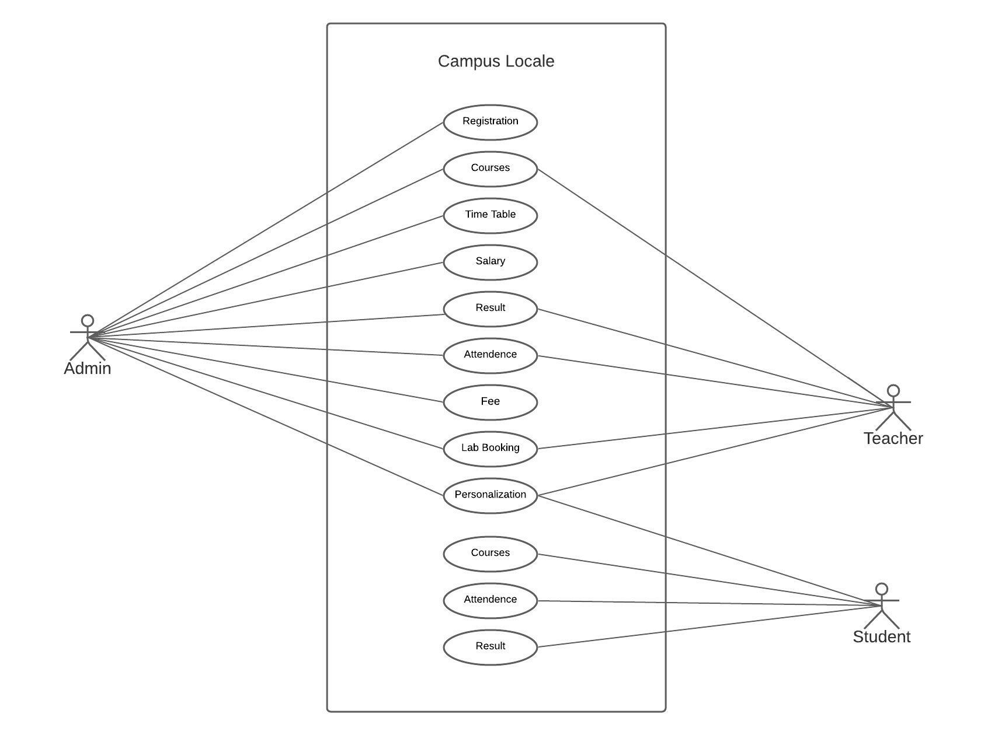

Sequence Diagram

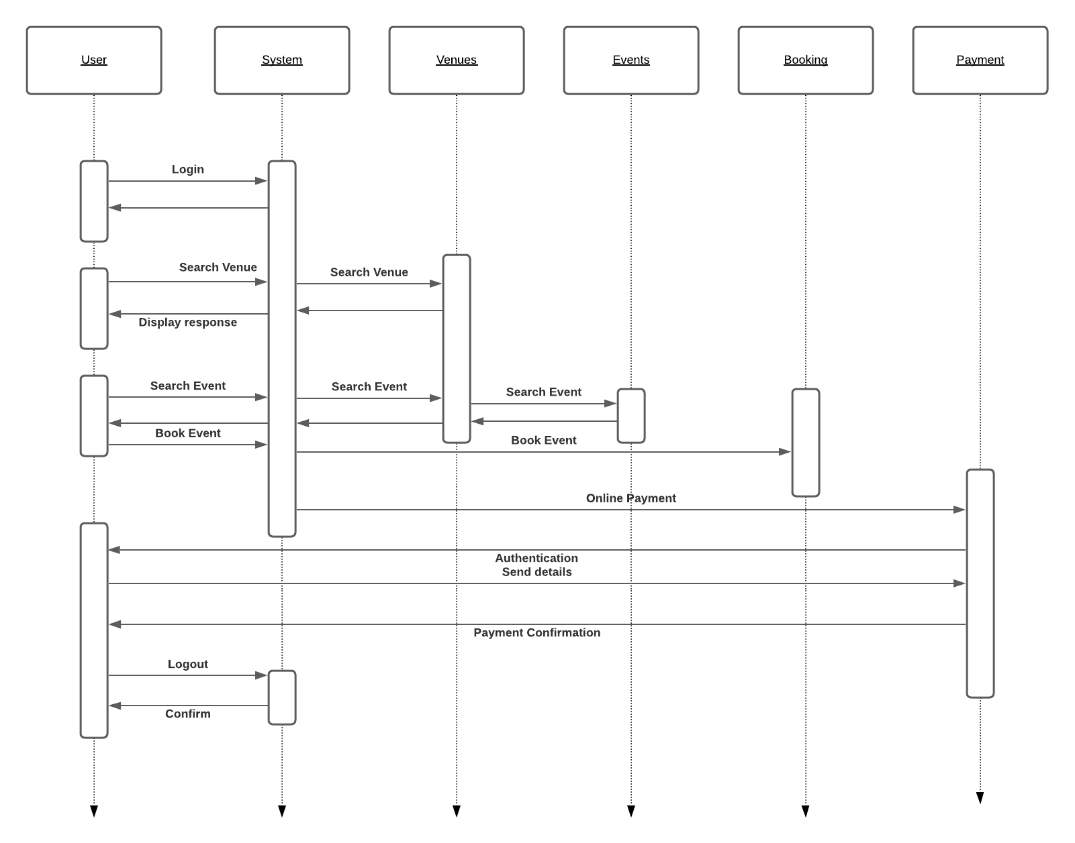

Object Diagram

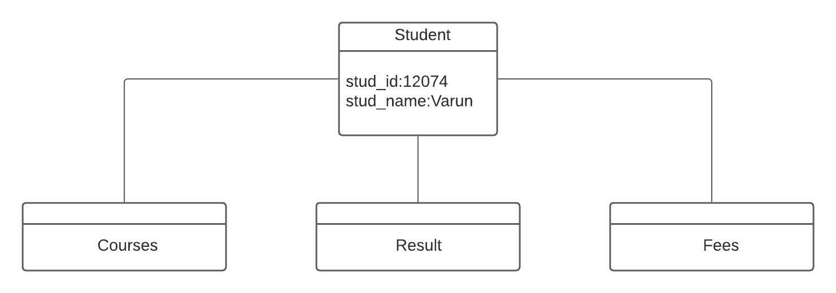

Class Diagram

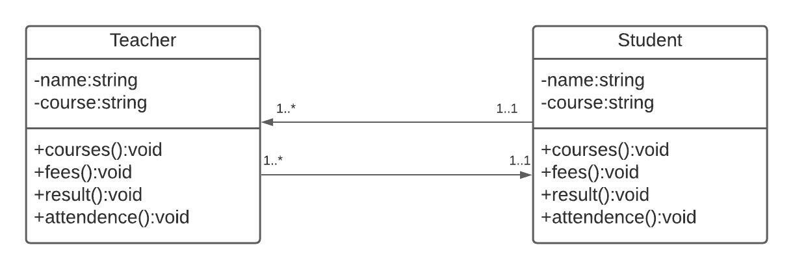

Componet Diagram:

